

MINI PROJECT REPORT ON

“ARDUINO BASED VEHICLE TRACKER USING GPS & GSM”

SUBMITTED BY:

**CHANDRASHEKHARAIAH (1NH18EC709)**

Under the guidance of

**RICHARD LINCOLN PAULRAJ**

Assistant Professor, Dept. of ECE, NHCE, Bengaluru

In partial fulfilment for the award of the degree of

BACHELOR OF ENGINEERING IN

ELECTRONICS & COMMUNICATION

# Abstract

A vehicle global positioning framework is helpful for following the development of a vehicle from any area whenever. An effective vehicle global positioning framework is planned and actualized for following the development of any prepared vehicle from any area whenever. The proposed framework utilized famous innovation that consolidates a cell phone with an Arduino UNO. This is simple to make and economical contrasted with others. The planned in vehicle gadget works utilizing Global Positioning System (GPS) and Global System for Mobile Communication (GSM) innovation that is quite possibly the most widely recognized ways for vehicle following. The gadget is implanted inside a vehicle those positions is to be resolved and followed continuously. An Arduino UNO is utilized to control the GPS collector and GSM module. The vehicle global positioning framework utilizes the GPS module to get geographic directions at ordinary time stretch. The GSM module is utilized to send and refresh the vehicle area to an information base. This paper gives step by step update about vehicle area by sending SMS through GSM modem. This SMS contain scope and longitude of the area of vehicle. Arduino UNO gets the directions from GPS modem and afterward it sends this data to client in content SMS. GSM modem is utilized to send this data through SMS shipped off the proprietor of the vehicle. Area is shown on mobile phone. And afterward Google map shows area and name of the spot-on mobile phone. In this manner, client ready to ceaselessly screen a moving vehicle on interest utilizing cell phone and decide the assessed distance and time for the vehicle to show up at a given objective.

**CHAPTER 01**

## INTRODUCTION

The rising instances of vehicle burglary, vehicle capture, seizing, redirection of raw petroleum and petroleum, change of course by drivers of transport organizations and robbery of significant holders and things in ocean ports have required the utilization of a more dependable security frameworks in vehicles and storerooms for important things. A security framework that can track, screen and give criticism of the area of the vehicle or compartment.

Vehicle global positioning framework fundamental point is to offer Security to all vehicles. Mishap ready framework fundamental point is to saving individuals in mishaps. This is improved security frameworks for vehicles. The most recent like GPS are exceptionally valuable now a days, this framework empowers the proprietor to notice and track his vehicle and discover vehicle development and its previous exercises of vehicle.

This new innovation, prominently called vehicle Tracking Systems which made numerous marvels in the security of the vehicle. This equipment is fitted on to the vehicle in such a way that it isn't obvious to any individual who is inside or outside of the vehicle. Subsequently it is utilized as a secret unit which persistently or by any hinder to the framework, sends the area information to the checking unit.

At the point when the vehicle is taken, the area information from global positioning framework can be utilized to discover the area and can be educated to police for additional activity. Some Vehicle global positioning framework can even identify unapproved developments of the vehicle and afterward alert the proprietor. This gives an edge over different bits of innovation for a similar reason.

The GPS based vehicle global positioning framework is intended to discover the specific area of any vehicle and personal the situation to the concerned authority about through a SMS. The framework incorporates a GPS modem that it recovers the area of a vehicle regarding its longitude and scope. The framework utilizes geographic position and time data from the GPS.

The framework has a locally available module that it dwells in the vehicle to be followed and a based station that screens information from the different vehicles. The installed module comprises of GPS recipient, a GSM modem. This equipment is fitted on to the vehicle in such a way that it was not obvious to anybody. That framework sends the area information to the checking unit constantly thusly it is utilized as a secret unit.

The framework consequently sends a return answer to that specific portable demonstrating the situation of the vehicle regarding scope and longitude when a solicitation by client is shipped off the number at the modem.

A program has been built up that it is utilized to find the specific situation of the vehicle and furthermore to explored track of the moving vehicle on Google map. The framework permits to follow the objective whenever and anyplace in any climate conditions. This framework is easy to use, effectively installable, effectively available and can be utilized for different other reason.

**CHAPTER 02**

# Literature Survey

|  |  |  |  |
| --- | --- | --- | --- |
| **Title of the Paper** | **Author and year of publication** | **Outcome** | **Limitation** |
| **GPS based vehicle tracking**  **and monitoring system** | Akshatha S.A | 1)GPS technology.    2) Raspberry Pi technology. | The comparison result can be displayed by the display unit. |
| **Hazza**  **Alshamisi,**  **Veton Kepuska** | “Real Time GPS  Vehicle Tracking System” | 1. GPS technology. 2. GSM technology. 3) Web technology. | 1)Fully web-based. 2) Unable to see location in case of internet failure.  3) Difficult in hardware implementation. |

**CHAPTER 03**

**PROPOSED METHODOLOGY**

# 3.1 Proposed System

The Exact area is demonstrated as scope and longitude alongside the specific Navigated track on Google map. The framework tracks the area of specific vehicle and ships off client versatile in type of information and furthermore to microcontroller. The showed up information, as scope and longitude is utilized to find the Vehicle on the Google maps and furthermore we can see the yield on the LCD.

## 3.2 Vehicle Tracking Features

It is mostly advantage for the organizations which depend on vehicle framework. Since it can show the situation of all vehicles continuously, so they can make the normal information appropriately. This global positioning framework can store the entire information where the vehicle had gone, where did it stop, how long it require at each stop and can make entire information examination. It is likewise utilized in transports and prepares, to assess what amount of time far are they, how long it requires for them to reach a specific stop. These frameworks are utilized to information catch, information stockpiling, information examination lastly information move. By adding extra sensors, for example, temperature sensor and infrared sensors the framework can be empowered to identify fire, robbery and deterrents.

## 3.3 Usage of Tracking In INDIA

Following in India is fundamentally utilized by transport frameworks, taxi organizations, traffic administrators. Taxi administrators utilize this to gauge how far the vehicle is from a specific territory and send this data to call focus and they can advise overall population about the distance of the taxi area and time it takes tom come to them. Another utilization is for traffic police if this framework is situated in each vehicle they can gauge the traffic by looking on the guide and on the off chance that any mishap is identified, at that point they can course the traffic in to another way. This is the means by which following is helpful in light of the fact that India is one of occupied traffic nations and this framework can handle a significant number of the traffic issues.

**CHAPTER 04**

# PROJECT DESCRIPTION

## 4.1 Software Description

Arduino IDE is an open-source programming that is basically used for forming and fusing the code into the Arduino Module.

It is a position Arduino programming, making code game plan too basic that even an ordinary individual with no prior particular data can consider betting everything with the learning technique.

It is adequately open for working structures like MAC, Windows, Linux and runs on the Java Platform that goes with inbuilt limits and bearings that expect a crucial employment for investigating, modifying and consolidating the code in the earth.

An extent of Arduino modules opens including Arduino Uno, Arduino Mega, Arduino Leonardo, Arduino Micro and some more. All of them contains a microcontroller on the board that is truly adjusted and recognizes the information as code. The rule code, in any case called a sketch, made on the IDE stage will in the end make a Hex File which is then moved and moved in the regulator on the board.

The IDE condition prevalently contains two basic parts: Editor and Compiler where past is used for forming the essential code and later is used for totaling and moving the code into the given Arduino Module. This condition supports both C and C++ lingos.

The Arduino writing computer programs is open-source. The source code for the Java condition is released under the GPL and the C/C++ microcontroller libraries are under the LGPL.

Sketch: The essential new stating is the Arduino program called "sketch".

## Structure

In this instructional exercise, we will find out about the Arduino programming program, bit by bit, and how we can compose the program with no linguistic structure or accumulation mistake.

Programming structure comprise of two primary capacities:

Software structure consist of two main functions:

1. Setup ( ) function
2. Loop ( ) function

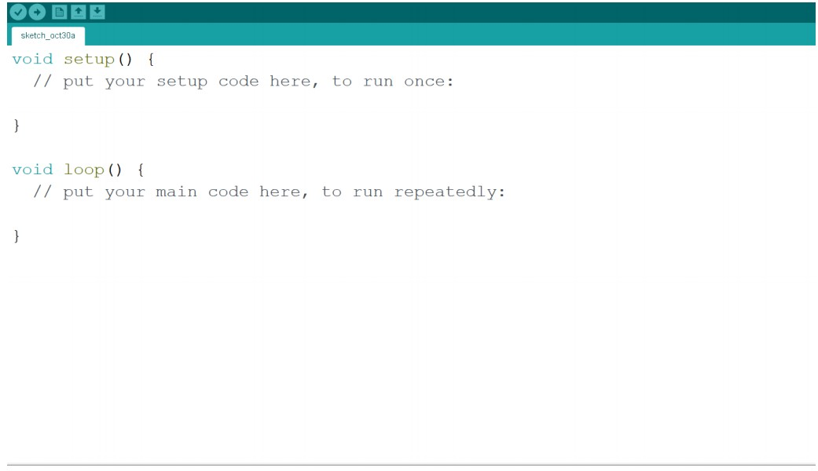

**Fig (4.1.1) Software Window**

## GSM and GPS Interfacing with Arduino Code to Track Vehicle Location

Void loop ()

{

Serial Event ();

If (temp)

{

Get_gps ();

Tracking ();

}

}

Functions void init_sms and void send_sms() are used to initializing and sending message.

Utilize appropriate 10-digit PDA no, in init_sms work.

Capacity void get_gps() has been utilized to remove the directions from the accepting string.

Capacity void gpsEvent() is utilized for getting GPS information into the Arduino. Void serialEvent()

{

While (Serial.available())

{

If (serial.find(“Track Vehicle”))

{

temp=1; break;

}

Introduction work 'gsm_init ()' is utilized for initialising and arranging the GSM Module, where right off the bat, GSM module is checked if it is associated by sending 'AT' order to GSM module. In the event that reaction OK is gotten, implies it is prepared. Framework continues checking for the module until it gets prepared or until 'alright' is gotten. At that point ECHO is killed by sending the ATE0 order, in any case GSM module will repeat all the orders. At that point at last Network accessibility is checked through the 'AT+CPIN?' order, whenever embedded card is SIM card and PIN is available, it gives the reaction +CPIN:

READY.

**4.2 Hardware Description**

## Circuit Diagram

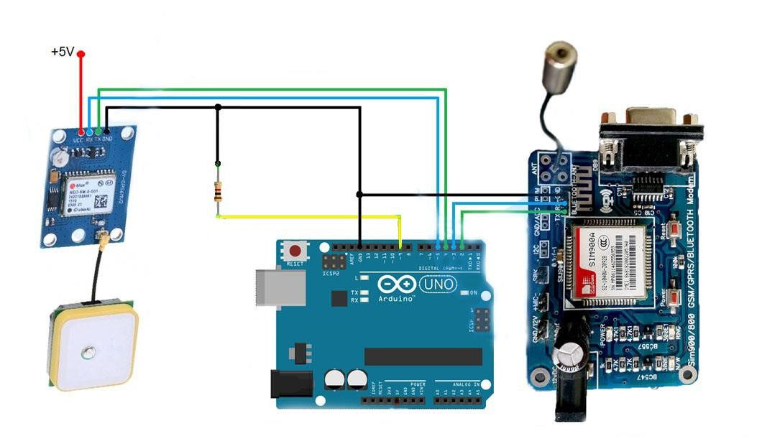

**Fig (4.2.1) Project Circuit Diagram**

# Block Diagram

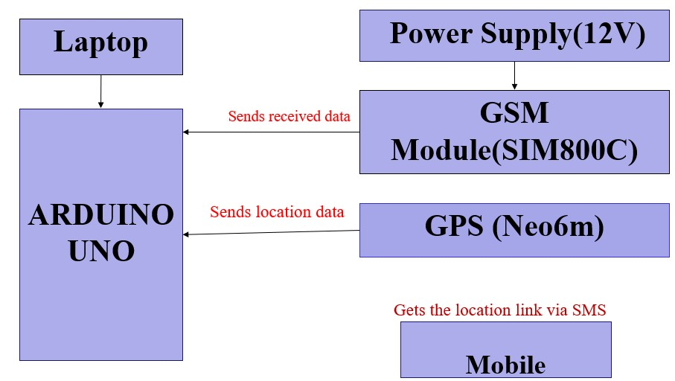

**Fig (4.2.2) Block Diagram**

# Components Used

1. Arduino Uno

1. GSM Module (SIM800C)

1. GPS Module (Neo6M)

1. Power supply (12V Adapter)

1. Connecting wires (jumper wires)

# Circuit Connections

* Connect Rx pin of GSM to the Arduino pin number 3 and connect Tx pin of GSM to the Arduino pin number 2.
* And then connect the GPS pin Rx to Arduino pin number 5 and connect Tx pin of GPS to the Arduino pin number 4.
* Connect the 12v(2A) Adapter to the GSM Module.
* And connect the ground of GPS, GSM to Arduino ground.
* Give a 5v supply voltage to the GPS.
* Connect the resistor to the Arduino pin number 9 and then connect to the ground.

# Description of Components

## 1. Arduino Uno

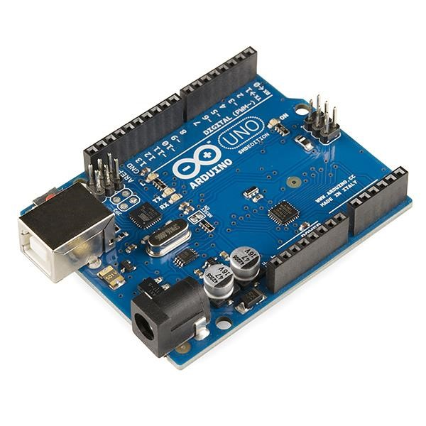

**Fig (4.2.3) Arduino Uno**

## Overview

The Arduino Uno is a microcontroller comprising of ATmega328p Microcontroller. It has 14 mechanized information/yield pins (of which 6 can be used as PWM yields), 6 basic information sources, a 16 MHz ceramic resonator, a USB affiliation, a force jack, an ICSP header, and a reset get. It contains all that normal to help the microcontroller; basically interface it to a PC with a USB connection or force it with an AC-to-DC connector or battery to start.

The Uno differs from each and every going before board in that it doesn't use the FTDI USBto consecutive driver chip. Or maybe, it incorporates the Atmega16U2 (Atmega8U2 up to variation R2) changed as a USB-to-consecutive converter. Update 2 of the Uno board has a resistor destroying the 8U2 HWB line to ground, making it more straightforward to put into DFU mode.

**Revision of the board has new features**

* It has more grounded Reset Circuit
* ATmega 8U2 is supplanted by the 16U2
* inout: added SDA and SCL pins that are close to the AREF pin and two other new pins are put close to the RESET pin. The IOREF that permit the shields to adjust the voltage gave from the board. The subsequent pin is a not associated pin, that is saved for additional reasons.

## Summary

1. Microcontroller ATmega328p
2. Operating Voltage 5Volts
3. Input Voltage (recommended) 7-12Volts
4. Input Voltage (limits) 6-20Volts
5. Digital I/O pins 14 ( 6 is PWM output )
6. Analog input pins 6
7. DC Current per I/O Pin 40 mAmps
8. DC Current for 3.3V Pin 50 mAmps
9. Flash Memory 32 KB of microcontroller of which 0.5 KB used by bootloader
10. SRAM 2 KB (microcontroller)
11. EEPROM 1 KB (microcontroller)
12. Clock Speed 16 MHz

## Input and Output

All the 14 digital pins on the Arduino Uno can be used as an input or output pins , using pinMode( ), digitalWrite( ), and digital Read( ) functions. They work at 5 volts. Each pin can send or get a limit of 40 maps and has an inner draw up resistor of 20-50kOhms.

* Serial: 0 (RX) and 1 (TX). They are utilized to get (RX) and communicate (TX) TTL sequential information. These pins can be connected to the corresponding pins of the ATmega328p USB-to-TTL Serial chip.
* External Interrupts: 2 and 3. These are the pins that can be configured to trigger an interrupt on a low value, a rising or a falling edge, or a change of the value.
* PWM: pins 3, 5, 6, 9, 10, and 11. They will provide 8-bit PWM output with the analogwrite () function in the programming.
* SPI: pin 10 (SS), 11 (MOSI), 12 (MISO), and 13 (SCK). These are the pins that support SPI communication using the SPI library.
* LED: 13. There is a built in LED connected to digital pin 13 to indicate high or low value. If the pin is HIGH value, the LED is on, when the pin is LOW value, it is off.
* The Arduino Uno has 6 analog inputs, from A0 through A5, each of which provide 10 bits Additionally, some pins have specialized functionality
* TWI: A4 or SDA pin and A5 or SCL pin. Support communication using the Wire library.
* There are a couple of other pins on the board:
* AREF. Reference voltage for the analog inputs. Used with analog Reference (). ➢ Reset. Bring this connection LOW to reset the microcontroller. Typically used to add a reset button to shields which acts to block the one on the board.

## 2. GSM Module (SIM800C)

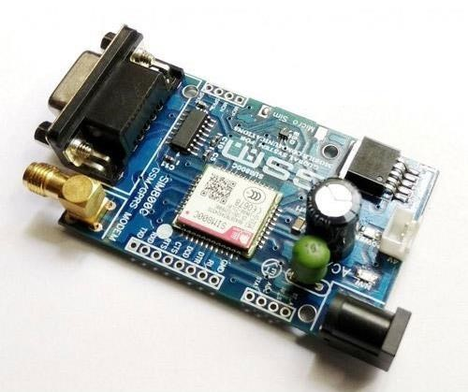

**Fig (4.2.4) GSM module**

## Overview

It likewise includes GPRS multi-opening class 12/class 10 (discretionary), and upholds CS-1, CS-2, CS-3, and CS-4 GPRS coding plans.

It has one UART port. It likewise has one USB port that can be utilized for refreshing firmware and for investigating. Sound channels are additionally there, which incorporate an amplifier input and a recipient output. SIM800 has one SIM card interface. It incorporates TCP/IP convention.

SIM800 can be controlled/arranged utilizing basic AT orders. A host microcontroller can send AT orders over the UART interface and control the SIM800.

SIM800 chips away at a reserve in the extent of 3.4 to 4.4V. It can be utilized for sending/accepting messages, settling on decisions, sending/getting information over the web, and so on This makes it helpful for applications, for example, home computerization, farming mechanization, and so forth.

## GSM Technology

The working of Global System for Mobile Communication (GSM) is much the same as a cell phone. It is essentially a modem on which a SIM is introduced and it works over a membership. GSM networks essentially contains three significant frameworks:

* The Switching System (SS)
* The Base System (BS)
* Mobile Station (MS)

## Features of GSM800

* Mobile to BTS (uplink): 890-915MHz
* BTS to Mobile (downlink): 935- 960 MHz
* Bandwidth: 2*25MHz

## The Switching System (SS)

SS comprises of five information bases that perform unmistakable capacities. Call preparing and endorser related capacities are its prime assignments. It has five databases which are as fallows

* Home Location Register (HLR),
* Visitor Location Register (VLR),
* Authentication Centre (AUC),
* Mobile Switching Centre (MSC)
* Equipment Identity Register (EIR)

## The Base Station System (BSS)

BSS has further two divisions viz. BTS and BSC. The base handset station (BTS) comprises of radio handsets. The quantity of handset stations increments with the size of the zone. The principle occupation of base station regulator is to deal with the radio assets for at least one handset stations. The association between the portable station and the versatile administrations community is encouraged by it.

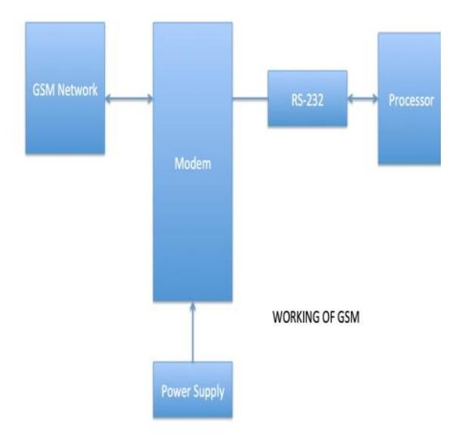

**Fig (4.2.5) Working of the GSM modem along with Arduino Uno**

## Mobile Station

The portable station comprises of versatile hardware and a keen card, which is ordinarily known as SIM (Subscriber's Identity Module). It grants customers to have passage to bought in organizations paying little mind to a specific terminal. Remembering the ultimate objective to settle on and get the decisions, the SIM is implanted to the GSM terminal. To distinguish the portable gear it utilizes International Mobile Equipment Number (IMEI). The SIM card is fitted with International Mobile Subscriber Identity that is used as a piece of the conspicuous verification of the ally of the structure and recognizing the supporter. The IMEI and IMSI are self-ruling.

## Microcontroller

ATMega328 is ATMEL Microcontroller on which Arduino UNO is made. It is a singular chip microcontroller made by AMTEL in mega AVR family. AVR is a gathering of microcontrollers made by Atmel. It encourages the interfacing of the GPS and the GSM module. Its utilization decreases the expense of the framework, and its little and conservative plan makes the gadget helpful.

## RS232 Protocol

Suggested Standard Number 232 (RS-232) a nonconcurrent convention for the sequential information trade. It characterizes shared conviction for voltage and sign level between Data Terminal Equipment (DTE) and Data Communications Equipment (DCE). Your PC is a DTE contraption, while most various devices are typically DCE devices. The ascribes, timing, which means of signs, actual size and pin out of connectors are characterized by this norm.

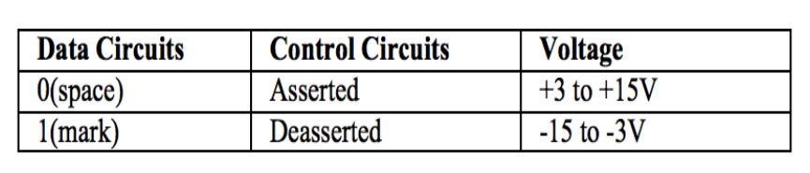

## 3. GPS Module (Neo 6M)

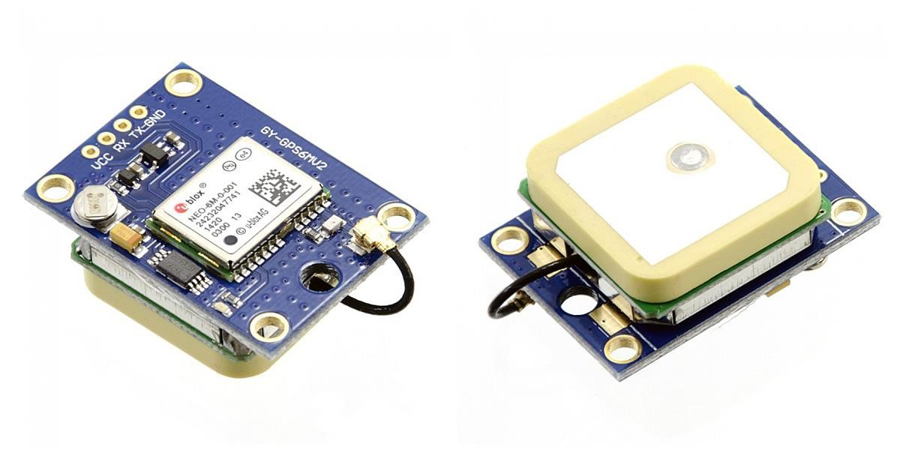

**Fig (4.3.1) GPS module**

## Overview

The NEO-6M GPS module is a well-performing total GPS recipient with an implicit 25 x 25 x 4mm artistic recieving wire. Which gives a solid satellite hunt ability. With the force and sign markers, you can screen the status of the module. On account of the information reinforcement battery, The module can save the information when the fundamental force is closed down coincidentally. Its 3mm mounting openings can guarantee simple get together on your airplane, which hence can fly consistently at a fixed position, re-visitation of home naturally, and programmed waypoint flying, Etc. Or on the other hand you can apply it on your savvy robot vehicle for programmed returning or making a beeline for a specific objective, making it a genuine "keen" bot!

The schematic graph of the module is demonstrated as follows:

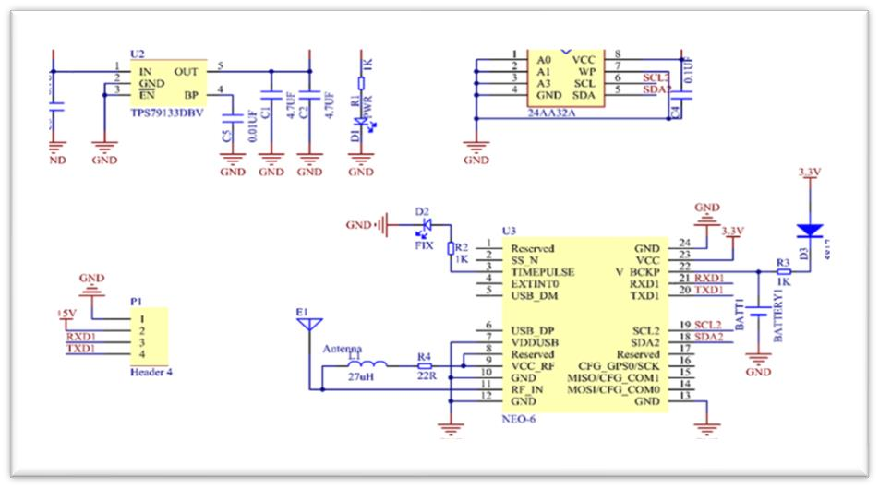

**Fig (4.3.2) GPS module schematic diagram**

## Features

1. The GPS module with the antenna is attached and a built in EEPROM to save configuration parameter data and to give latitude and the longitude values.
2. Built in the 25 x 25 x 4 mm ceramic active antenna which gives the strong satellite to access.
3. Equipped with the power and the signal indicator light and the data backup battery in it.
4. Power supply ranges from 3-5V, Default baud rate is 9600 bps.

## Test

In this test, we will send the situating information gathered by the NEO-6M GPS Module to the product on the PC, and contrast this outcome and that of a standard GPS gadget.

Subsequently we can know if this module works.

## 4. Android App

The Android application remembered for the task has been composed, tried and repaired in the Android Studio. The Figure 5 shows the application interface when the application is opened on the Android client. When the client presses the Request Location button', a SMS to the gadget is shipped off bring the directions of the vehicle's area. This area is then plotted in the application.

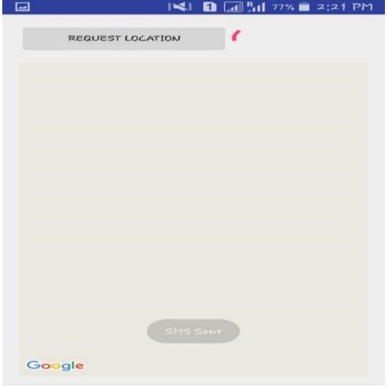

**Fig (4.4.1) Android app interface of the receiver station**

## EXPERIMENTAL RESULTS

The gadget was tried in Vellore Institute of Technology. It was discovered that the area of the vehicle was anticipated viably in the majority of the cases. Notwithstanding, the area appeared in the application can have a blunder of roughly 10 meters because of constraint in the equipment.

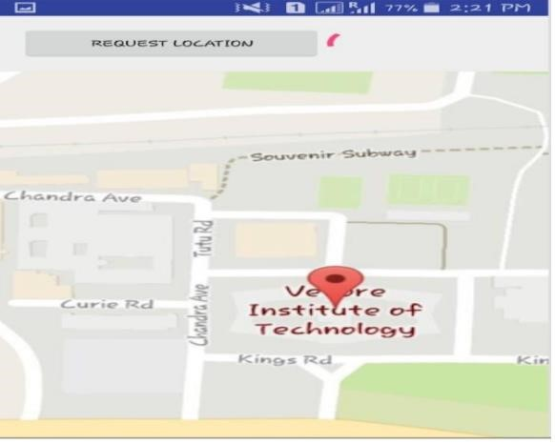

**Fig (4.4.2) The location of vehicle**

## USABILITY

It is very easy to use. To know the vehicle's area, each of the a client needs to do is to type an instant message on the versatile and send it to the SIM number introduced in the gadget. It is secure as just the area of the gadget will be shipped off the enrolled versatile client.

**Adapter and wires**

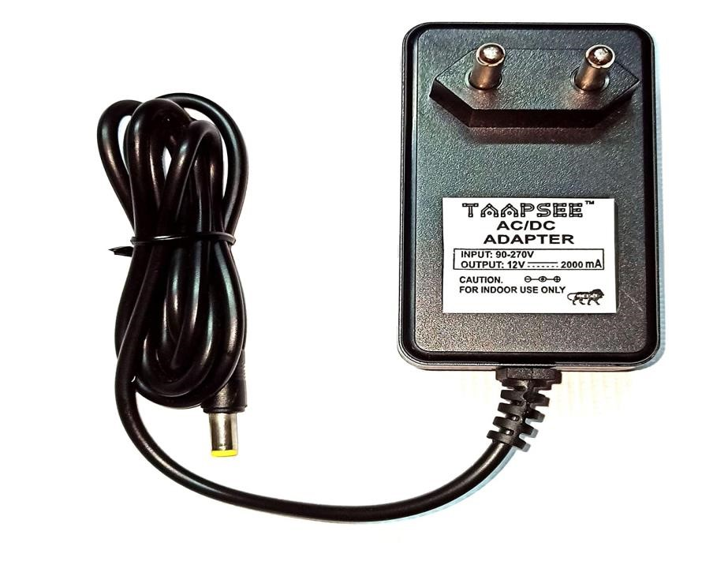

**Fig (4.4.3) 4 supply (12V Adapter)**

## Overview

At first, most AC/DC connectors were immediate power supplies, containing a transformer to change over the mains power voltage to a lower voltage, a rectifier to transform it over to pulsating DC, and a channel to smooth the throbbing waveform to DC, with leftover wave varieties adequately little to leave the controlled gadget unaffected Size and weight of the contraption was generally constrained by the transformer, which consequently was directed by the power yield and mains repeat. Appraisals over a couple of watts made the gadgets excessively huge and weighty to be truly upheld by a divider source. The yield voltage of these connectors changed with load; for gear requiring a steadier voltage, direct voltage controller hardware was added. Mishaps in the transformer and the straight regulator were noteworthy; viability was for the most part low, and enormous impact scattered as warmth regardless, when not driving a load.

From the get-go in the twenty-first century, exchanged mode power supplies (SMPSs) turned out to be practically omnipresent for this reason. Mains voltage is corrected to a high immediate voltage driving an exchanging circuit, which contains a transformer working at a high recurrence and yields direct current at the ideal voltage. The high-repeat swell is more helpfully filtered through than mains-repeat. The high recurrence permits the transformer to be little, which lessens its misfortunes; and the exchanging controller can be significantly more productive than a direct controller. The outcome is a substantially more proficient, more modest, and lighter gadget. Wellbeing is guaranteed, as in the more seasoned direct circuit, on the grounds that a transformer actually gives galvanic seclusion.

A straight circuit should be intended for a particular, slender scope of info voltages (e.g., 220– 240 VAC) and should utilize a transformer proper for the recurrence (generally 50 or 60 Hz), yet an exchanged mode supply can work effectively over a wide scope of voltages and frequencies; a solitary 100–240 VAC unit will deal with practically any mains supply on the planet.

Be that as it may, except if painstakingly planned and utilizing appropriate segments, exchanging connectors are bound to fall flat than the more seasoned sort, due to some degree to complex hardware and the utilization of semiconductors. Except if planned well, these connectors might be effectively harmed by over-burdens, even transient ones, which can emerge out of lightning, brief mains overvoltage (at times brought about by a glowing light on a similar force circuit coming up short), segment corruption, and so on An exceptionally regular method of disappointment is because of the utilization of electrolytic capacitors whose equal arrangement obstruction (ESR) increments with age; exchanging controllers are extremely delicate to high ESR (the more established direct circuit additionally utilized electrolytic capacitors, yet the impact of debasement is significantly less sensational). Very much planned circuits focus on the ESR, swell current rating, beat activity, and temperature rating of capacitors.

Numerous cheap exchanged mode AC connectors don't execute satisfactory sifting as well as protecting for electromagnetic obstruction that they produce. The idea of these rapid, highenergy exchanging plans is with the end goal that when these protection measures are not executed, generally high energy sounds can be created, and transmitted, all the way into the radio bit of the range. The measure of RF energy normally diminishes with recurrence; along these lines, for example, obstruction in the medium wave (US AM) broadcast band in the one megahertz area might be solid, while impedance with the FM broadcast band around 100 megahertz might be extensively less. Distance is a factor; the closer the impedance is to a radio recipient, the more serious it will be. Indeed, even WiFi gathering in the gigahertz reach can be debased if the getting radio wires are extremely near a transmitting AC connector. An assurance of if obstruction is coming from a particular AC connector can be made essentially by unplugging the speculate connector while noticing the measure of impedance got in the difficult radio band. In a cutting edge family unit or business climate, there might be various AC connectors being used; in such a case, unplug them all.

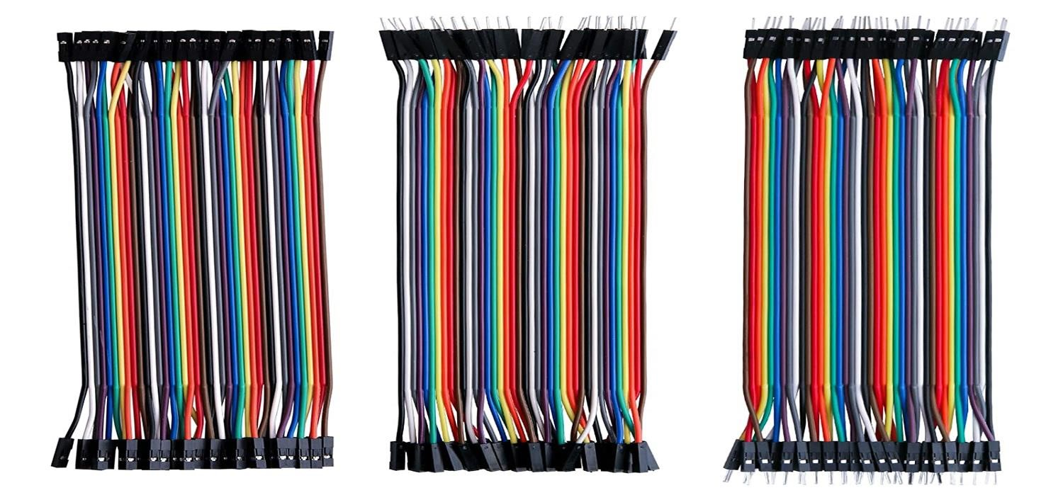

**Fig (4.4.4) Jumper wires**

**CHAPTER 05**

## Result and discussion

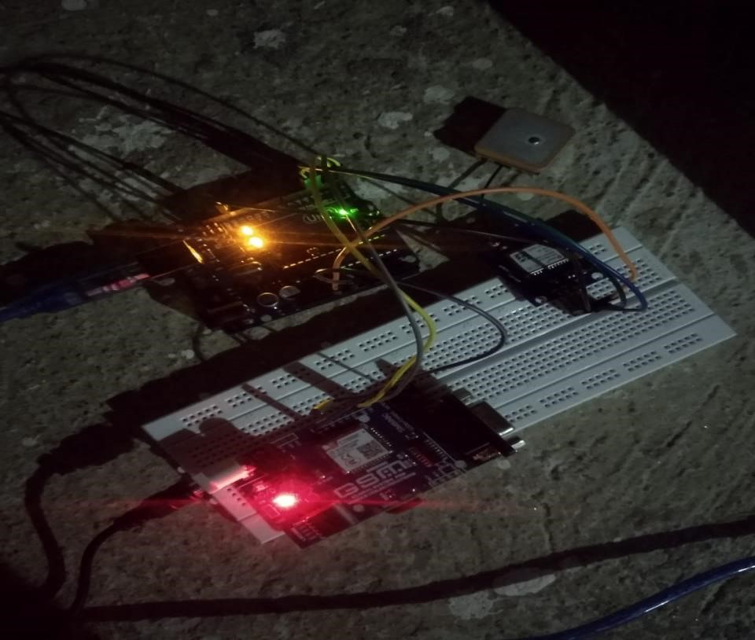

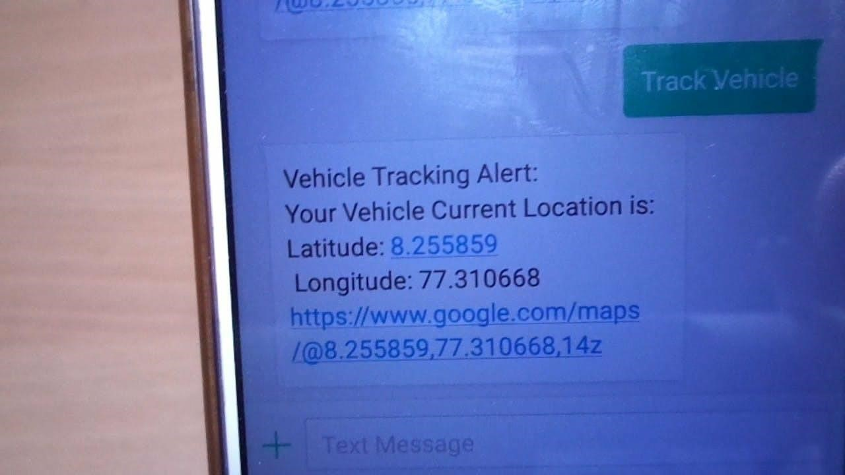

**Fig (5.1) Project General Pictures**

**CHAPTER 06**

## ADVANTAGES AND APPLICATIONS

**Advantages of the project:**

* GSM trackers are efficient over scanning of RFID, hence there will be more reliability.
* As the problem of network coverage is reducing, more and more network towers are put up, the systems efficiency will increase.
* Security against theft.
* Fleet management will become easy, so the user can be stress-free by using this system in their vehicles.

**Applications of the Project:**

* It can be used for school buses, city buses, to know their location.
* Useful for car and motorcycle rental companies, can have an eye on their clients who rented their vehicles.
* This system is highly useful for transport companies which transport goods from one place to another.

**CHAPTER 07**

## CONCLUSION AND FUTURE SCOPE

**Conclusion:**

* The expanded interest for vehicle global positioning frameworks for following the burglary of vehicles through GPS and GSM technology. This technology can be utilized for both individual and business purposes to improve wellbeing and security, correspondence, and execution checking.
* Vehicle global positioning technology have gotten progressively significant in enormous urban areas and is more secure among the existing frameworks. These days, vehicle robbery is quickly expanding. With this innovation in any case, vehicle robbery can be better controlled.
* This innovation can likewise assist with propelling transportation frameworks, and can be utilized in numerous associations for security and following purposes.
* The increase in network connectivity in the world will be very useful in improving the efficiency of the technology.

**FUTURE SCOPE:**

* Collision sensors can be added to the system which can be placed all around the vehicle, emergency contacts can be pre -registered in the memory of the system, when in case of a serious collision, this system can be used to send information to the concerned people for help.
* Data can be sent to a server, and the location can be accessed by a website using internet.

**REFERENCE:**

1. Albert Alexe, R. Ezhilarasie, “**Cloud Computing Based Vehicle Tracking Information Systems**”, ISSN: 2229 - 4333 (Print) | ISSN: 0976 - 8491 (Online) IJCST Vol. 2, Issue 1, March 2011.
2. Ambade Shruti Dinkar and S.A Shaikh, **Design and Implementation Of Vehicle Tracking System Using GPS, Journal of Information Engineering and Applications**, ISSN 2224-5758, Vol 1,No.3, 2011.
3. Real Time Vehicle Tracking System using GSM and GPS Technology- An Anti-theft Tracking System January 2012 Authors: Mandeep Singh.